**FixSQLMSI Readme**

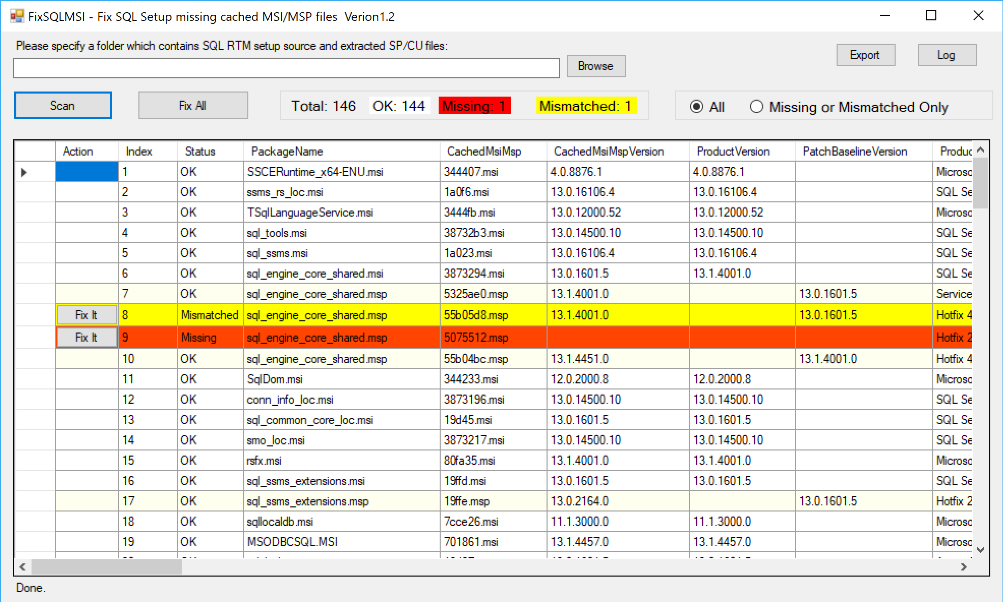

1.



If you specify this setup source folder, this tool will scan all those *.MSI and *.MSP files inside it and use their product code to scan the registry key, to find out whether any cached MSI/MSP files are missing in C:\WINDOWS\INSTALLER directory, and will prepare command(s) to fix the missing files.

If you don’t specify this folder this tool may fail to find the MSI/MSP for those missing/mismatched files and hence you are not able to fix them. For some cases although you don’t input this folder but this tool can still be able to find the missing MSI/MSP from its LastUsedSource folder of the installed product.

The best practice is that you put SQL server RTM setup media and all subsequent service packs, CUs to the same folder, for example:

C:\SQLMedia\RTM

C:\SQLMedia\SP1

C:\SQLMedia\SP1CU1

…

If you download service packs or CUs from the website, please remember to extract its package using X switch to the folder. For example, below command extract SP1 to SP1 subfolder:

SQLServer2016SP1-KB3182545-x64-ENU.exe /X

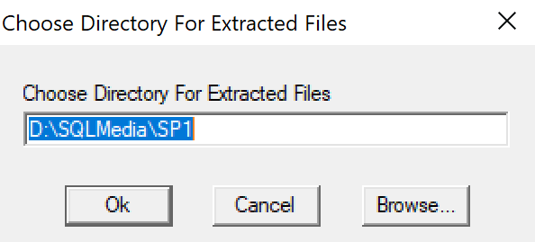

If you don’t extract the package it is not helpful even if the package is in the same folder.

2.



**OK** means cached MSI/MSP exists and their product version matched.

**Missing** means the cached MSI/MSP files are missing.

**Mismatched** means cached file are there but their product name or version are not matched with the expected values.

3.



The option is to switch how the grid shows the data

4.



Scan the registry key to find SQL server products.

5.



Fix all missing/mismatched automatically. However if expected MSI/MSP file is not found from setup source folder or lastUserSource the fix will fail.

6.

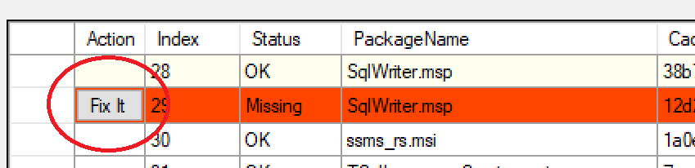

“Fix It” Action will try to fix the missing MSI/MSP for this item.

7.

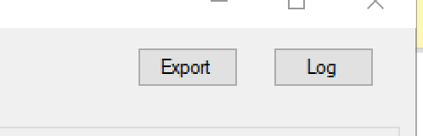

Export button will save the rows to txt file and csv file. Txt file is readable and csv file can be viewed in excel.

Log button to show the run time log of the tool. If any error thrown it will be save in the log.

Readable txt:

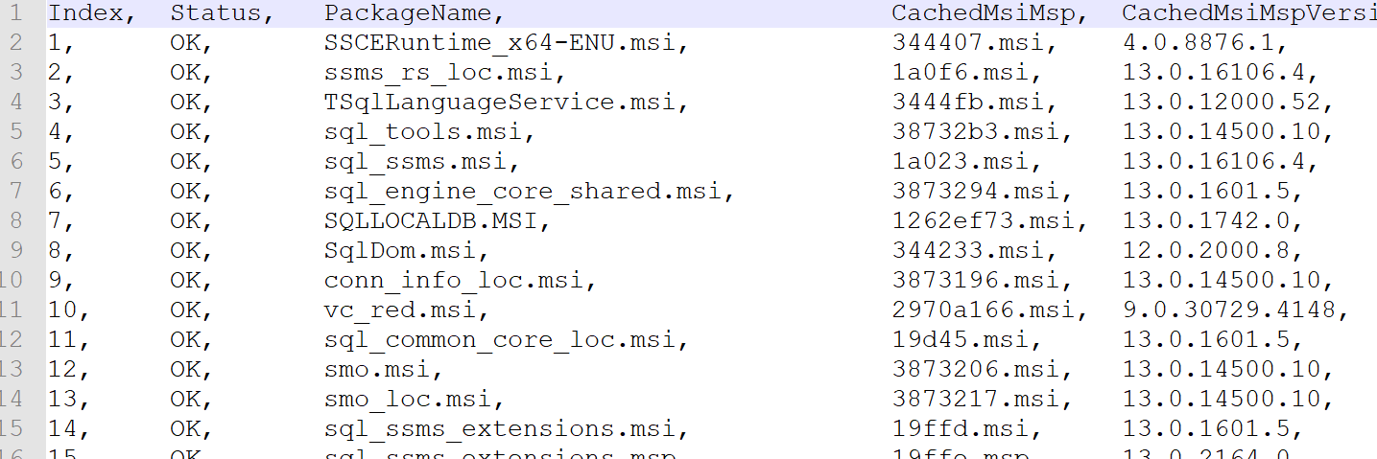

Csv file In excel:

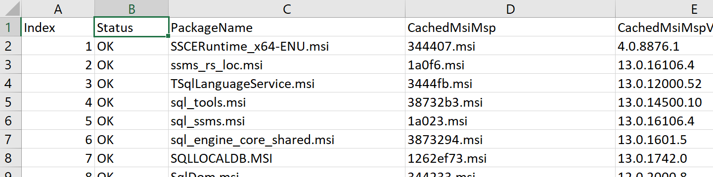

8.



Each column is sortable if you click it. And you can drag/drop the column header to change their order.

9.

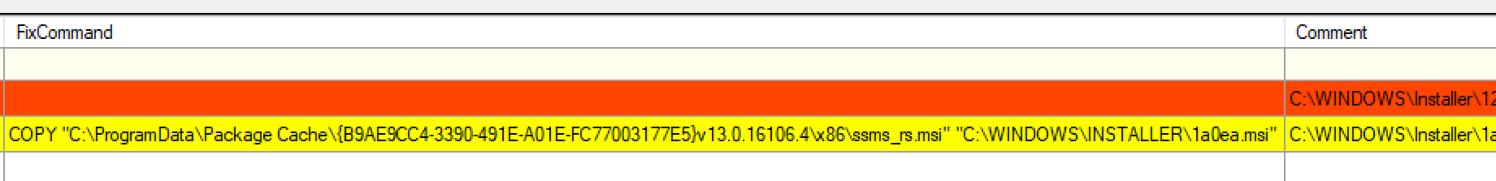

FixCommand is the command how to fix the missing/mismatched file.

Comment has more information about the command.

10.

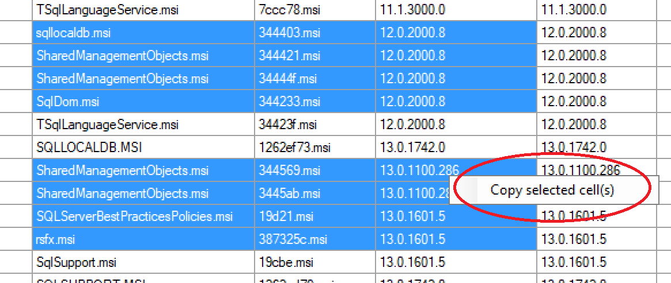

Right click the selected cells you can copy them to clipboard.